Week 2 Documentation: Responsive Web Design
Project: Radio Tarang 91.1, a fictional community radio station website Files: index.html, styles.css, images/, screenshots/

1. Plan
The site is a single page with six parts: header and navigation, hero, show cards, weekday schedule, newsroom stories, a support sign-up and a footer. I picked a radio station because it naturally contains the content types that are hard to make responsive: a data table (the schedule), a card grid, feature stories with large images and a navigation bar.
I designed mobile-first. The base CSS is the phone layout, and every media query only adds what a larger screen can handle. This keeps the CSS short, because phones never have to undo desktop rules.

2. Methods used
Technique | Where it is used | Why
Fluid type with clamp() | All font sizes (--fs-h1, --fs-body, etc.) | Text scales smoothly instead of jumping at breakpoints
Fluid spacing with clamp() | --gap, --section-pad | Whitespace grows with the screen
min() for container width | .wrap | Side margins on phones, a max width on desktops, with no media query
CSS Grid auto-fit + minmax() | .card-grid | Cards go from 1 to 2 to 4 columns automatically
Container query | .stories (@container stories) | The story layout depends on the space available to it, not on the screen
Media queries (min-width) | 600px, 900px, 1200px | Schedule table, navigation, hero, footer and form layout
Media queries (other features) | max-height + orientation, hover: hover, prefers-reduced-motion | Landscape phones, touch vs mouse, motion preferences
<picture> with <source media> | Hero image | Art direction: a squarer crop on phones, a wide crop on larger screens
Fluid images | img { max-width: 100%; height: auto }, aspect-ratio, object-fit: cover | Images never overflow or distort
width/height attributes + loading="lazy" | All images | Reserves space (no layout jump) and delays off-screen images
Responsive table | .schedule | Real table on wide screens, stacked labelled cards on phones
CSS-only hamburger menu | Header | Works without JavaScript
Viewport units svh | Hero height | Avoids the mobile browser toolbar cutting off the hero

3. Breakpoints and why they sit there
I chose breakpoints where the content stopped fitting, not at device names.
Width | What changes
Base (under 600px) | One column. Hamburger menu. Buttons stack full-width. Schedule rows become cards. Sign-up form stacks.
600px and up | Buttons sit side by side. Sign-up form becomes one row. Schedule becomes a table with a header row.
900px and up | Hamburger replaced by an inline menu. Hero text aligns to the content grid. Support section and footer become columns.
1200px and up | Maximum content width increases from 70rem to 76rem.
Two things change without any media query: the show cards (auto-fit grid) and the story cards (container query, switching at 40rem and 56rem of container width).

4. How the design adjusts
I checked the page in headless Chromium at three widths. At each width the page’s scroll width equalled the viewport width, so there is no horizontal scrolling. Full-page screenshots are in screenshots/.
Device | Viewport | Navigation | Show cards | Schedule | Stories
Phone | 375px | Hamburger | 1 column | Stacked labelled cards | 1 column
Tablet | 768px | Hamburger | 2 columns | Table | Feature on top, two cards below
Desktop | 1280px | Inline menu | 4 columns | Table | Feature with image beside text, two cards below
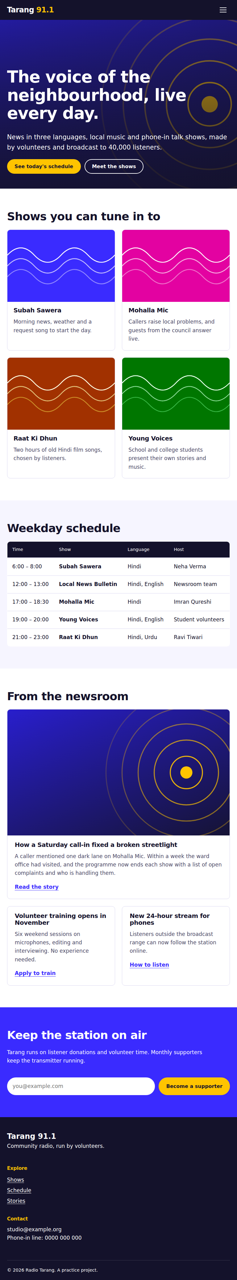
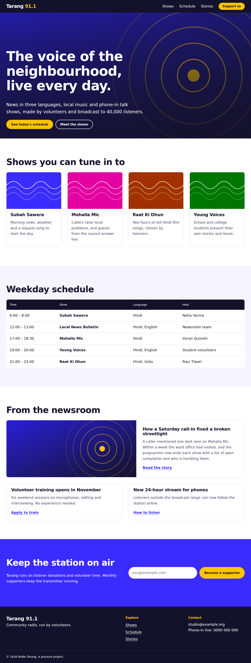
Desktop, 1280px

5. Challenges and solutions
- A container cannot style itself in a container query. My first version put container-type and the grid on the same element, so the two-column story layout never applied. I wrapped the cards in an inner .stories-grid so the query targets a child of the container.
- Tables do not shrink. A four-column table overflows on a phone. Instead of horizontal scrolling, I turned each row into a card and used data-label attributes with ::before { content: attr(data-label) } to show the column names. The header row stays in the DOM, hidden visually, so screen readers still get it.
- Hero text readability over an image. White text crossed the bright rings of the image on narrow screens. I added a dark gradient layer with ::before and used a different image crop on phones.
- Hero cut off by mobile browser toolbars. vh includes the area behind the toolbar. Using svh (small viewport height) fixed it.
- Hamburger without JavaScript. A visually hidden checkbox plus a <label> toggles the menu with the :checked selector. I kept the checkbox focusable and added a visible focus outline so keyboard users can open it.
- Fluid sizes versus accessibility. Using only vw units can stop text from zooming when the user increases browser font size. Each clamp() mixes rem and vw, so zoom still works.

6. Accessibility notes
Skip link, one h1 with a logical heading order, labelled navigation landmarks, a table caption and scope attributes, a hidden but present form label, visible focus styles, and prefers-reduced-motion support.

7. How to test it yourself
- Open index.html in Chrome or Edge, press F12, then Ctrl+Shift+M to toggle the device toolbar.
- Drag the width from 1400px down to 320px and watch the three breakpoints.
- Test the device presets (iPhone, iPad) and rotate to landscape.
- Zoom the browser to 200% to confirm text and layout still hold.
- Confirm there is no horizontal scrollbar at any width.

8. Limitations
- Tested in headless Chromium only, not on physical devices or in Safari and Firefox.
- Images are simple SVG illustrations. For photographs, I would add srcset and sizes with multiple widths.
- Container queries and svh need a modern browser (2023 or later).

